Tutorial 6.3

Stan Wan

## Step 1: Simulation of E-I oscillator

Used parameters and variables according to the tutorial. Stimulated the equations for 2.5s using a time-step of ∆𝑡 = 0.1ms. Plotted the firing rates of excitatory and inhibitory units in the same graph. (line 1 - 91)

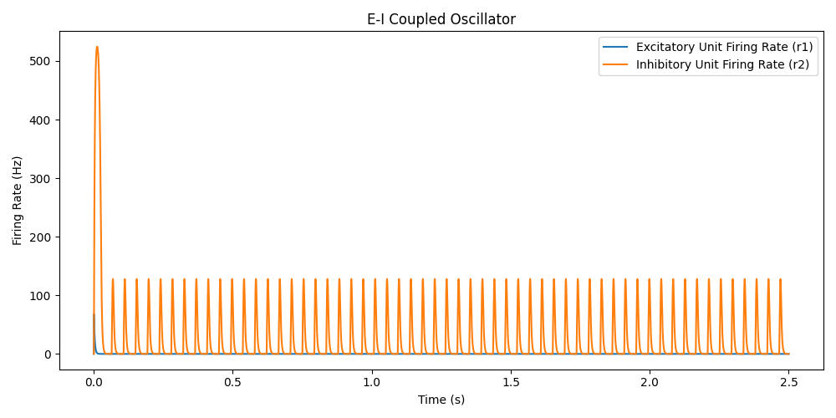

To calculate the frequency, taking periods 0.5s to 2.5s, where I counted 48 oscillations, frequency = spikes / time = 24Hz. The large spike in the inhibitory unit firing rate (r2) at t = 0 is probably due to the initial input conductance G_in(1) = 1e-9 S causing a nonzero effective excitatory input even at time zero, while all state variables (r1, r2, s_E, s_I) are initialized to zero.

## Step 2: Automatic Calculation of the Frequency of Oscillation

Defined oscillations thresholds and an indicator to detect oscillations, and finally calculated the precise oscillation period: 0.0439s.

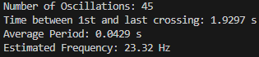

It mostly aligns with the result from step 1, but the difference exists possibly due to inaccurate counting. (line 93 - 130)

## Step 3: Computation of Power Spectrum *P(f)*

Created a vector and computed two frequencies equals to sin(2pi*f*t) and cos(2pi*f*t), and combined them as following：

Plotted 𝑃(𝑓) as a function of the frequency vector.

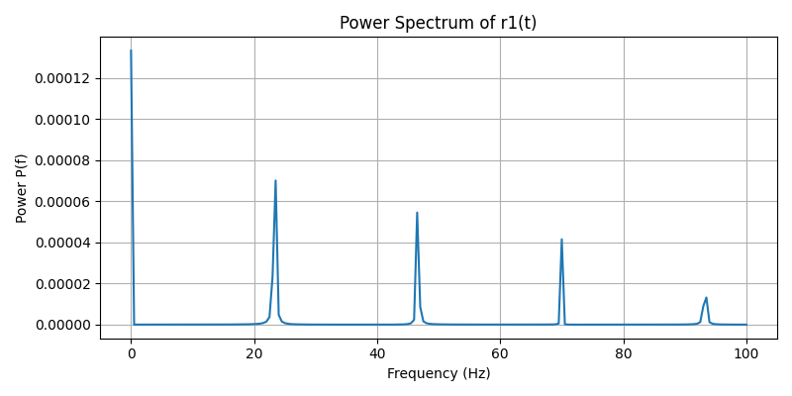  
Because cos (0 * t) = 1, sin (0 * t) = 0, P(0) = mean(r1​)^2. It only measures the mean of the firing rate, which is large due to non-zero baseline. P(0) only reflects the direct current but not oscillations so it does not fulfill our purpose of finding fluctuating activity.

There are multiple peaks in the graph. Since the peak frequency tells the dominant oscillation frequency, the peaks represent the frequency at which oscillations occur the most. I noticed that the peaks are declining gradually, and the frequency is multiples of the first peak around 22Hz. This might indicate that the oscillations overlap at the multiples of the baseline frequency.

(line 133 - 167)

## Question 4 & 5: Effects of Input Conductance Variation

Used example codes from figure 6.14. Figure on the left was produced by 0nS inhibitory input and 0 - 10 nS excitatory input. The one on the right had constant 2nS excitatory input and 0 - 25 pS inhibitory input.

The pattern of the results of question 4 is very similar to figure 6.14 on the tutorial. The inhibitory unit plots increases steeply at first and then gradually increases, and dominated over excitatory unit.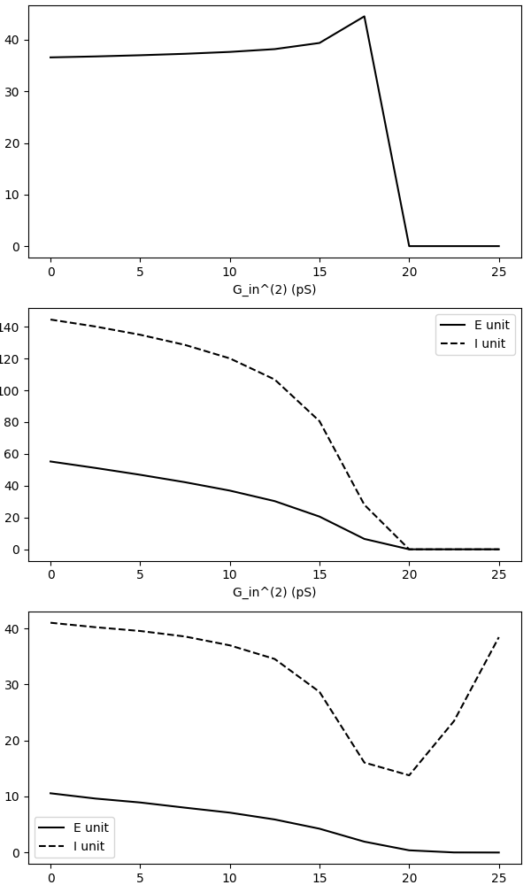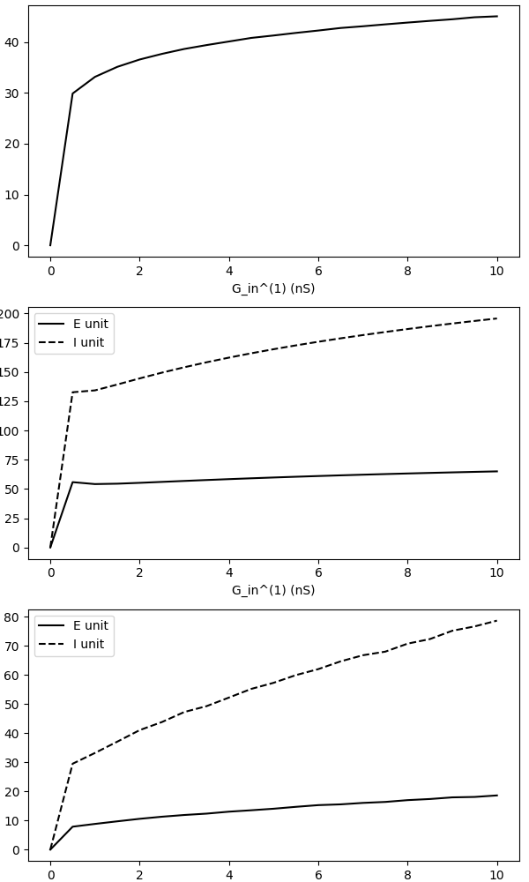

For question 5, the oscillation frequency is steady and dropped rapidly after a small increase at around 17nS. The amplitude and mean firing rate also declined along with increasing G_in(2). The inhibitory unit is still the dominant one, and is affected more.

(Separated python scripts)